 

Learning From Data

Neural Network Coding (Task 1)

Weather Prediction

|  |  |
| --- | --- |
| Name | ID |
| فؤاد سيد فؤاد | 20200384 |
| حسن سمير حسن | 20200154 |
| حسن تامر علي | 20200152 |
| أحمد سامح أحمد | 20200015 |
| سارة صامويل لامي | 20200217 |

اشراف: ا. د. الشيماء الجندي

2022م-2023م

Description of the preprocessing steps:

* We read data with data CSV, we get information of data and we find that there are 4 features has an object data type.
* We find that the column “precip type” has 517 null values.
* We filled a null values with “Rain” because it was a mode.
* We find 24 duplicate row and dropped them.
* We made a histogram for each column then we found that there aren’t outliers.
* We divide “formatted data” column into 4 another columns “year, month, day, hour” then dropped “formatted data”.
* We dropped “daily summary” and “loud cover”.
* We make Encoder for “summary”,” precip type” by get dummies (built in function in pandas’ library).
* We make correlation for data.
* We added a “bias” column equal one.

Train test split implementation from scratch:

* We divided the data set into 70% for training model and 30% for test model.
* We divided the data set into inputs data and target “humadity”.
* We implemented MLNN from scratch.

Description of the network architecture:

* Number of layers: 3

Input, Hidden, Output

* Neurons: 51

40 for input, 10 for hidden, 1 for output

* Activation function type:

Sigmoid forward propagation

Sigmoid differentiation backward propagation

Comment on resulting graph:

chart with a horizontal axis titled “Epoch number” ranging from 1 to 10, and a vertical axis titled “MSE”.

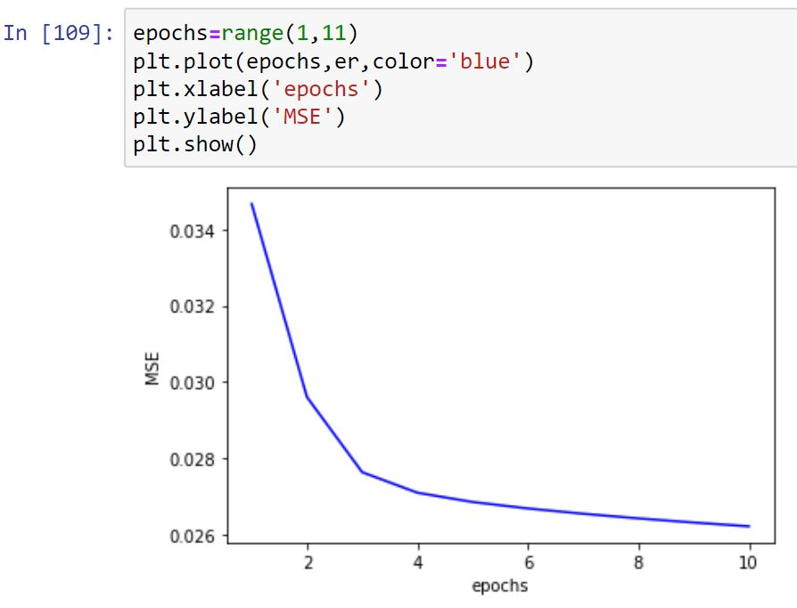

chart with a horizontal axis “sample of 200 row from Test” and a vertical axis target titled “Humadity”.

